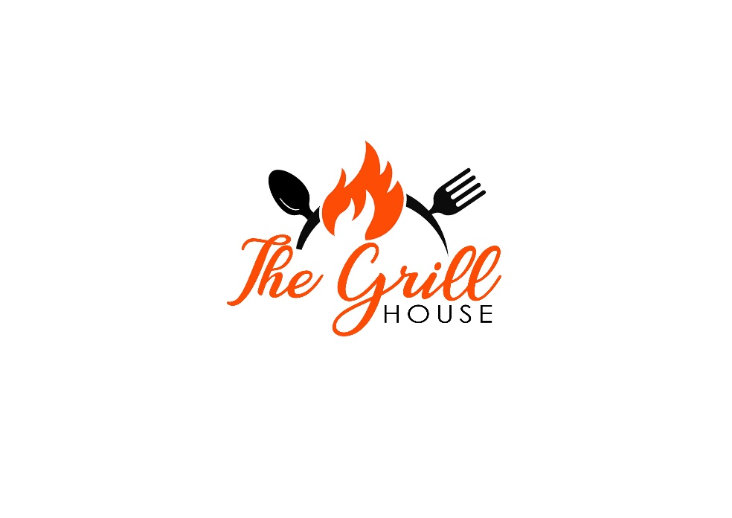

Our Story…

Once upon a time, in the heart of the owners, Ana and Bogdan, harboured a shared dream of bringing the authentic flavours of Romania to life through their own restaurant. Both had a deep passion for traditional Romanian cuisine and a burning desire to share it with the world.

Bogdan, a skilled chef with years of experience in some of the finest kitchens across UK, and Ana, a warm-hearted and creative soul, decided to combine their talents to create a dining experience that would not only tantalize taste buds but also capture the essence of Romanian culture.

After months of meticulous planning and tireless efforts, the duo found the perfect location for their restaurant. They named their establishment The Grill House, and they spared no effort in decorating the restaurant with elements that reflected the rich history and heritage of Romania. Wooden beams painted in a rustic brown, and vibrant folk art adorned the walls. The atmosphere is warm and inviting, reminiscent of a traditional Romanian home.

Ana and Bogdan poured their hearts into developing a menu that showcased the diverse and delicious dishes from various regions of Romania, complemented by the delicious and aromatic Romanian and Moldavian wines.

From hearty mamaliga (polenta) to savoury sarmale (cabbage rolls), each dish is a testament to their commitment to authenticity and quality.

STARTERS

Mici - iconic skinless sausages that hold a cherished place in Romanian cuisine £11.95
A blend of ground beef and pork, seasoned with garlic, thyme, oregano and paprika, served hot, with Romanian mustard and home-made flat bread.
(Allergens: mustard, gluten)

Trio of home-made starters (V) £13.95
Vegetable conserve, grilled aubergine dip with home-made lemon mayo and white bean paté, served with home-made flat bread.
(Allergens: gluten, egg, mustard, sulphites)

Crispy squid £9.95
Deep fried squid, served with home-made lemon mayo and salad.
(Allergens: molluscs, gluten, soy, eggs, mustard)

Panko prawns £9.95
Breaded deep fried prawns, served with sweet chilli sauce and salad.
(Allergens: crustaceans, gluten)

Halloumi chips (V), (GF) £8.95
Served with salad and sweet chilli sauce.
(Allergens: milk)

Garlic bread (V) £8.95
Home-made flat bread covered with home-made garlic butter.
(Allergens: gluten, milk)

We use all fresh ingredients, cooked to order. Please allow time for this!
We will do our best to comply with our guests’ dietary requirements. Therefore, please inform us about your dietary requirements, prior ordering, so we can explain the ingredients from our dishes. As all our food is prepared in our small kitchen, allergen-based meals are prepared in the same deeply cleaned area as allergy free meals.
For groups of 6 people or more, pre-order and deposit of £10pp required, non-refundable if the booking is cancelled in less than 24 hours and a 10% service charge will be added to the final bill.

ROMANIAN DISHES

Gipsy style spicy hot pan £19.95
Tender chicken combined with a flavourful mix of pork, sausages, onions, peppers, chili, and garlic, served with home-made bread and sour cream.
(Allergens: soy and may contain traces of milk, celery, mustard and gluten)

Dracula’s meat platter for 2-3 people £65
Succulent grilled pork and chicken, both marinated to perfection, Romanian sausages, grilled vegetables, skin on fries, gherkins, salad, and mustard.
(Allergens: soy, sulphites and may contain traces of milk, celery, mustard and gluten)

Ciulama £16.95
Rich and comforting dish featuring tender chicken pieces simmered in a velvety cream and mushrooms sauce and served with polenta.
(Allergens: gluten, milk)

Tochitura £18.95
Traditional Romanian pork, chicken and Romanian sausages stew, slow-cooked and served with golden polenta, topped with a fried egg and crumbled Romanian telemea cheese.
(Allergens: soy and may contain traces of milk, celery, mustard and gluten, milk, egg)

Romanian Burger (8 OZ) £17.95
A hearty burger made with a traditional Romanian mix of pork and beef, seasoned to perfection, grilled for a smoky flavour, and served with tangy mustard and crunchy gherkins for a bold, savory bite, served with skin on fries.
(Allergens: sulphites, gluten, mustard, sesame seeds)

Mixed grill skewers £18.95
Flavourful skewers loaded with succulent pork and traditional Romanian sausages, grilled to perfection for a smoky, savory taste, served with skin on fries and salad.
(Allergens: sulphites and may contain traces of celery, gluten, mustard and soy)

Chicken and vegetable skewers (GF) £17.95
Juicy chicken skewers grilled with courgette, mushrooms, cherry tomatoes, and aubergine, offering a colourful and flavourful medley of tender meat and charred vegetables, served with skin on fries and salad.
(Allergens: sulphites)
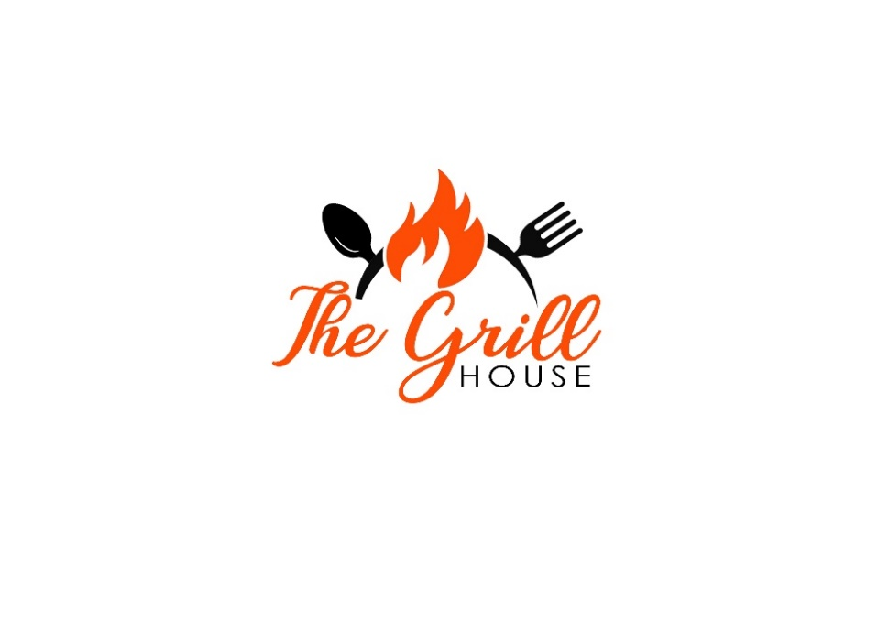

ON THE GRILL

T-BONE pork chop £19.95
Mouthwatering bone-in tomahawk pork chop, marinated in a sweet and savory sauce with mustard, garlic, Worcestershire sauce and soy and then grilled to perfection, served with roasted garlic potatoes and chimichurri sauce.
(Allergens: mustard, fish, soy)

Chicken burger £16.95
Grilled chicken breast layered with rich cheddar cheese, fresh beef tomato slices, crisp lettuce, and topped with a zesty homemade lemon mayo for a refreshing citrus kick in every bite, served with skin on fries.
(Allergens: milk, egg, mustard)

10 oz Sirloin steak (locally sourced, 28 days matured) (GF) £26.95
With home-made garlic butter or blue cheese sauce, served with grilled mushrooms, grilled cherry tomatoes on the vine, skin on fries and salad.
(Allergens: milk, sulphites)

Grilled chicken thighs £16.95
Juicy grilled chicken thighs marinated in a bold blend of mustard, garlic, and soy sauce, served with a traditional Romanian garlic sauce made from roasted tomatoes and charred peppers and accompanied by crushed roasted baby potatoes.
(Allergens: mustard, fish, soy)

Grilled chicken breast (GF) £17.95
Tender grilled chicken breast, marinated in lemon, garlic and herbs, served with a rich mushroom and caper sauce, accompanied by crushed roasted baby potatoes.
(Allergens: milk)

The biggest cheesy chicken schnitzel in Bexhill £18.95
An extra-large chicken schnitzel coated in crispy golden breadcrumbs, generously topped with melted cheddar and served with skin-on fries and salad.
(Allergens: milk, gluten, sulphites)

The Grill House Veggie Burger (V) £15.95
Grilled vegetables and halloumi, home-made mayo, red onion rings, beef tomato, lettuce, served with skin on fries.
(Allergens: gluten, egg, mustard, milk)

SIDES

Hand-cut skin on fries with thyme and rosemary salt (V, VE, GF) £4.50
Roasted potatoes with garlic butter (V, GF) £4.95
(Allergens: milk)
Goose fat roasted baby potatoes £4.95
Grilled vegetables (V, VE) £6.95
(courgette, mixed peppers, aubergine, mushrooms, red onions)
Sweet potato fries (V, VE, GF) £4.95

DESSERTS

Papanasi £9.95
Traditional Romanian fried cheese doughnut, served hot and topped with sour cream and blackcurrant jam, offering a delicious contrast of creamy, sweet, and tangy flavours.
(Allergens: gluten, milk, egg)
Apple cake with vanilla ice-cream £8.95
Caramelized traditional Romanian apple cake is a beloved homemade dessert made with soft sponge cake layered over tender apples caramelized in sugar and butter. This upside-down style cake is moist, fragrant, and rich in flavour—a comforting classic in Romanian cuisine.
(Allergens: gluten, milk, egg, sulphites)

Chocolate mousse (GF) £8.95
Light and velvety chocolate mousse served with fresh seasonal fruits for a perfect balance of richness and freshness.
(Allergens: milk, egg)

COLD DRINKS

Soft drinks: Coke, Diet Coke 330ml £4
Schweppes Lemonade 200ml £2.80
Schweppes Tonic Water 200ml £3
J2O Apple and Raspberry 275ml £3.50
J2O Orange and Passion fruit or Apple and Mango £3.50
J2O Apple and Mango 275ml £3.50
Highland still water 330ml £2.90
Highland Mineral water 330ml £2.90
Apple Juice/Cranberry Juice/Orange Juice £2.50

HOT DRINKS

Espresso single / double £2.50 /£3
Latte £3.60
Flat white £3.40
Cappuccino £3.80
Americano £3
Tea £3
English tea, camomile, peppermint, lemongrass, red bush, green tea
Hot chocolate £3.50
Add flavours to your coffee – vanilla, hazelnut or caramel - £0.70




WINES 125 ml 175 ml Bottle
A leader in the winemaking industry, boasting two centuries of rich history, Chateau Purcari remains loyal to its true values, continuing to create outstanding wines.

WHITE WINE
125ml 175ml Bottle

Cervus Cepturum £6.25 £7.75 £26
Sauvignon Blanc Dry, Romania (aromas of passion fruit and lime)
Cervus Cepturum £6.50 £7.95 £27
Muscat Ottonel Sweet, Romania (honey, nuts and tropical fruits)
Domeniile Cuza £7.15 £8.95 £30

Sauvignon Blanc Dry, Romania (grapefruit, green apple, lime and elderflower)
Chardonnay Purcari £7,50 £9.50 £34
Republic of Moldova (exotic aromas, with notes of peaches and mangos)
Purcari £7,50 £9.50 £34
Pinot Griggio Dry, Republic of Moldova (pear, peach and floral notes)
Viorica de Cricova £36
Dry, Republic of Moldova (citrus, basil and hints of honey and pear)

ROSÉ WINE

125 ml 175ml Bottle

Wine Crime £6.75 £8.15 £27
Aromas of red and exotic fruit and peony flowers.
Rosé de Cricova £7.15 £8.95 £30
Taste: strawberry, raspberry and red currant.
Rose de Purcari (special edition) £36

RED WINE 125 ml 175 ml Bottle

125ml 175ml Bottle

Cricova £6.25 £7.75 £26
Cabernet Sauvignon, Dry, Romania (blackcurrants, cherries and violet scent)
Domeniile Cuza £7.25 £9.15 £32
Malbec, Republic of Moldova (black cherries, dry plums and blackcurrants)
Purcari (Limited edition) £8.50 £11.95 £39
Malbec, Dry, Republic of Moldova (blackberries, black currants and violets)
Purcari £7,50 £9.50 £34
Pinot Noir Dry, Republic of Moldova (velvety, floral, fruity, vanilla spiced)
Rara Neagra de Cricova, Dry, Republic of Moldova £34
(fruity, smooth, floral, plight, elegant)

SPARKLING WINE

PROSECO White Dry £8.50 £26
PROSECO Rosé Spumante £8.50 £26
Romanian/Moldavian White Sparkling wine £9.15 £28

BOTTLED BEERS

Corona Extra 330ml - £4.95
Birra Moretti 330 ml - £4.45
Romanian blonde beer 330ml - £4.50
Peroni 0% alcohol 330 ml - £4

SPIRITS

DUGLADZE Brandy VSOP (10 years old) / Metaxa Brandy 7*
Single 25 ml - £6.50 Double - £11
GORDON’S GIN Single 25 ml - £4.50 Double - £6.50
BAILEYS Single 25 ml - £4.75 Double - £6.75
ABSOLUT VODKA Single 25 ml - £5.50 Double - £7.50
JOHNNIE WALKER Single 25 ml - £7.50 Double - £12
TIA MARIA Single 25 ml - £4.75 Double - £6.75
JAMESON WHISKEY Single 25 ml - £4.50 Double - £6.50
BACARDI RUM Single 25 ml - £4.50 Double - £6.50
SABER BLUEBERRY/SOURCHERRY ROMANIAN LIQUEUR
Single 25 ml - £4.50 Double - £6.50

V – VEGETARIAN
VE – VEGAN
GF – GLUTEN FREE
TAKE AWAY BOXES - £0.50

